5.87: See Exercise 5.15 (Atwood’s machine). The 2.00-kg block will accelerate upward at 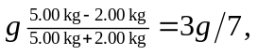 and the 5.00-kg block will accelerate downward at 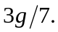 Let the initial height above the ground be 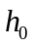; when the large block hits the ground, the small block will be at a height 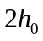, and moving upward with a speed given by 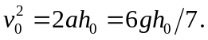 The small block will continue to rise a distance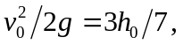 and so the maximum height reached will be 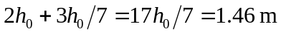, which is 0.860 m above its initial height.

